**FPT ACADEMY INTERNATIONAL**



## FPT – APTECH COMPUTER EDUCATION

National Park

|  |  |  |  |
| --- | --- | --- | --- |
| **Center Name** | | FPT – Aptech – HCM2  Address: 590 Cach Mang Thang Tam, District 3, Ho Chi Minh City | |
| **Instructor** |  | Ms. Le Mong Thuy |  |
| **Class** |  | T1.2008.A0 |  |
| **Group** |  | 4 |  |
| **Group members** | | **Name** | **Student ID** |
|  |  | Phan Phuc Thinh | Student1275061 |
|  |  | Tran Trong Nhan | Student1275059 |
|  |  | Le Nguyen Trung Truc | Student1273006 |
| **Duration** | Start date | 13th November 2020 |  |
| End date | 9th December 2020 |  |

**This is to certify that**

**Mr.:**

Phan Phuc Thinh

Tran Trong Nhan

Le Nguyen Trung Truc

**has successfully designed & developed**

eProject: National Park

**Submitted by:**

Phan Phuc Thinh

**Date of issue:**

**Authorized Signature:**



**TABLE OF CONTENTS**

FPT – APTECH COMPUTER EDUCATION 1

ACKNOWLEGMENT 4

SYNOSIS 4

PROBLEM DEFINITION 4

CUSTOMER'S REQUIREMENTS SPECIFICATIONS (CRS) 5

Business/Project Objective: 5

Hardware/ Software Requirements: 6

SCOPE OF THE WORK (IN BRIEF) 7

Architecture and design of the system 8

Diagram of the website 9

TASK SHEET REVIEW 1 10

SITE MAP 11

MOCK OF THE WEBSITE 12

**1.** **Homepage** 12

**2.** **Asia** 13

**3.** **North American** 14

**4.** **Africa** 15

**5.** **Plan your visit** 16

**6.** **Thing to see & do** 17

**7.** **Plant and animal** 18

**8.** 19

**9.** 20

**10.** 21

TASK SHEET REVIEW 2 22

WEBSITE DESCRIPTION 23

**1.** **Home Page** 23

**2.** **Asia** 25

**3.** **North american** 26

**4.** **Africa** 27

**5.** **Plan your visit** 29

**6.** **Thing to see & do** 30

**7.** **Plant and animal** 30

**8.** 31

**9.** 32

**10.** 32

TASK SHEET REVIEW 3 34

# ACKNOWLEGMENT

On behalf of all the members of group 5, I would like to thank you all for the hard works, supports to make this eProject complete successfully. Especially, Ms. Le Mong Thuy, our teacher, she helped us a lot from the day that we started to study at FPT Aptech. With this eProject, she has guided us with her enthusiasm and rigorous, because of her guiding, we would be able to finish this project. Besides, I want to thank all the team member of group 5, each of the team member has been working continuously in 4 weeks in order to complete this project. The last but not least, we would like to say thank you to our family for always supporting us, creating the best conditions for us to focus on the project, and putting faith in the dreams we pursue.

# SYNOSIS

A **national park** is a [park](https://en.wikipedia.org/wiki/Park) in use for [conservation](https://en.wikipedia.org/wiki/Conservation_(ethic)) purposes, created and protected by national governments. Often it is a reserve of natural, semi-natural, or developed land that a sovereign state declares or owns. Although individual nations designate their own national parks differently, there is a common idea: the conservation of 'wild nature' for posterity and as a symbol of national pride.[[1]](https://en.wikipedia.org/wiki/National_park#cite_note-1)

An international organization, the [International Union for Conservation of Nature](https://en.wikipedia.org/wiki/International_Union_for_Conservation_of_Nature) (IUCN), and its [World Commission on Protected Areas](https://en.wikipedia.org/wiki/World_Commission_on_Protected_Areas) (WCPA), has defined "National Park" as its *Category II* type of [protected areas](https://en.wikipedia.org/wiki/Protected_areas).[[2]](https://en.wikipedia.org/wiki/National_park#cite_note-2) According to the IUCN, 6,555 national parks worldwide met its criteria in 2006. IUCN is still discussing the parameters of defining a national park.[[3]](https://en.wikipedia.org/wiki/National_park#cite_note-3)

While this type of national park had been proposed previously, the United States established the first "public park or pleasuring-ground for the benefit and enjoyment of the people", [Yellowstone National Park](https://en.wikipedia.org/wiki/Yellowstone_National_Park), in 1872.[[4]](https://en.wikipedia.org/wiki/National_park#cite_note-4) Although Yellowstone was not officially termed a "national park" in its establishing law, it was always termed such in practice[[5]](https://en.wikipedia.org/wiki/National_park#cite_note-5) and is widely held to be the first and oldest national park in the world. However, the [Tobago Main Ridge Forest Reserve](https://en.wikipedia.org/wiki/Tobago_Main_Ridge_Forest_Reserve) (established in 1776),[[6]](https://en.wikipedia.org/wiki/National_park#cite_note-6) and the area surrounding [Bogd Khan Uul Mountain](https://en.wikipedia.org/wiki/Bogd_Khan_Mountain) (1778) are seen as the oldest legally [protected areas](https://en.wikipedia.org/wiki/Protected_area), predating Yellowstone by nearly a century.[[7]](https://en.wikipedia.org/wiki/National_park#cite_note-7)[[8]](https://en.wikipedia.org/wiki/National_park#cite_note-8)

# PROBLEM DEFINITION

In 1969, the IUCN declared a national park to be a relatively large area with the following defining characteristics:[[12]](https://en.wikipedia.org/wiki/National_park#cite_note-12)

* One or several [ecosystems](https://en.wikipedia.org/wiki/Ecosystems) not materially altered by human exploitation and occupation, where plant and animal species, geomorphological sites and habitats are of special scientific, educational, and recreational interest or which contain a natural landscape of great beauty;
* Highest competent authority of the country has taken steps to prevent or eliminate exploitation or occupation as soon as possible in the whole area and to effectively enforce the respect of ecological, geomorphological, or aesthetic features which have led to its establishment; and
* Visitors are allowed to enter, under special conditions, for inspirational, educative, cultural, and recreative purposes.

# CUSTOMER'S REQUIREMENTS SPECIFICATIONS (CRS)

**Client: National Park**

In 1971, these criteria were further expanded upon leading to more clear and defined benchmarks to evaluate a national park. These include:

* Minimum size of 1,000 hectares within zones in which protection of nature takes precedence
* Statutory legal protection
* Budget and staff sufficient to provide sufficient effective protection
* Prohibition of [exploitation of natural resources](https://en.wikipedia.org/wiki/Exploitation_of_natural_resources) (including the development of dams) qualified by such activities as sport, hunting, fishing, the need for management, facilities, etc.

### Business/Project Objective:

Customer, Travel guide.

**Input to the system:**

While national parks are generally understood to be administered by national governments (hence the name), in Australia national parks are run by state governments and predate the [Federation of Australia](https://en.wikipedia.org/wiki/Federation_of_Australia); similarly, national parks in the Netherlands are administered by the provinces.[[9]](https://en.wikipedia.org/wiki/National_park#cite_note-Gissibl,_B._2012-9) In Canada, there are both national parks operated by the federal government and provincial or territorial parks operated by the provincial and territorial governments, although nearly all are still national parks by the IUCN definition.

**Output from the system:**

### Early references[[edit](https://en.wikipedia.org/w/index.php?title=National_park&action=edit&section=3)]

In 1810, the English poet [William Wordsworth](https://en.wikipedia.org/wiki/William_Wordsworth) described the [Lake District](https://en.wikipedia.org/wiki/Lake_District) as a "sort of national property, in which every man has a right and interest who has an eye to perceive and a heart to enjoy."[[15]](https://en.wikipedia.org/wiki/National_park#cite_note-15) The painter [George Catlin](https://en.wikipedia.org/wiki/George_Catlin), in his travels through the [American West](https://en.wikipedia.org/wiki/American_West), wrote during the 1830s that the [Native Americans in the United States](https://en.wikipedia.org/wiki/Native_Americans_in_the_United_States) might be preserved "(by some great protecting policy of government) ... in a *magnificent park* ... A *nation's Park*, containing man and beast, in all the wild and freshness of their nature's beauty!"[[16]](https://en.wikipedia.org/wiki/National_park#cite_note-16)

Starting in 1735 the [Naples government](https://en.wikipedia.org/wiki/Kingdom_of_Naples) undertook laws in order to protect Natural areas, which could be used as a [game reserve](https://en.wikipedia.org/wiki/Game_reserve) by the royal family; [Procida](https://en.wikipedia.org/wiki/Procida) was the first protected site;[[17]](https://en.wikipedia.org/wiki/National_park#cite_note-17) the difference between the many previous royal hunting preserves and this one, which is considered to be closer to a Park rather than a hunting preserve,[[18]](https://en.wikipedia.org/wiki/National_park#cite_note-18) is that Neapolitan government already considered the division into the present-day wilderness areas and non-strict nature reserves.

**Process**:

### Early references[[edit](https://en.wikipedia.org/w/index.php?title=National_park&action=edit&section=3)]

In 1810, the English poet [William Wordsworth](https://en.wikipedia.org/wiki/William_Wordsworth) described the [Lake District](https://en.wikipedia.org/wiki/Lake_District) as a "sort of national property, in which every man has a right and interest who has an eye to perceive and a heart to enjoy."[[15]](https://en.wikipedia.org/wiki/National_park#cite_note-15) The painter [George Catlin](https://en.wikipedia.org/wiki/George_Catlin), in his travels through the [American West](https://en.wikipedia.org/wiki/American_West), wrote during the 1830s that the [Native Americans in the United States](https://en.wikipedia.org/wiki/Native_Americans_in_the_United_States) might be preserved "(by some great protecting policy of government) ... in a *magnificent park* ... A *nation's Park*, containing man and beast, in all the wild and freshness of their nature's beauty!"[[16]](https://en.wikipedia.org/wiki/National_park#cite_note-16)

Starting in 1735 the [Naples government](https://en.wikipedia.org/wiki/Kingdom_of_Naples) undertook laws in order to protect Natural areas, which could be used as a [game reserve](https://en.wikipedia.org/wiki/Game_reserve) by the royal family; [Procida](https://en.wikipedia.org/wiki/Procida) was the first protected site;[[17]](https://en.wikipedia.org/wiki/National_park#cite_note-17) the difference between the many previous royal hunting preserves and this one, which is considered to be closer to a Park rather than a hunting preserve,[[18]](https://en.wikipedia.org/wiki/National_park#cite_note-18) is that Neapolitan government already considered the division into the present-day wilderness areas and non-strict nature reserves.

**Expected delivery date:** 09-dec -2020.

**List of deliverables:**

* + - * Document Word.
      * User Guide.
      * Source code.

### Hardware/ Software Requirements:

* **For developer**

**Hardware**

* + Intel Pentium 4 processor or higher
  + 1 Gigabytes of RAM or higher

**Software**

* + Windows 7 OS or higher
  + Adobe Dreamweaver
  + Web browsers such as IE, Chrome or Firefox are supporting HTML5, CSS3 and Javascript.
* **For web users**

**Hardware**

* + Intel Pentium 4 processor or higher
  + 512 Megabytes of RAM or higher

**Software**

* + Windows XP OS or higher
  + Web browsers such as IE, Chrome or Firefox are supporting HTML5, CSS3 and Javascript.

# SCOPE OF THE WORK (IN BRIEF)

After a long and detailed discussion, our group has decided to create a website contain the following webpages:

1. ***Homepage***: Display information about newest-selling products, an introduction about Nationnal park.
2. ***Asia***: website talking about parks in Asia
3. ***Europe*** : website talking about parks in Europe
4. ***Africa***: website talking about parks in Asia
5. ***Thing to see & do***: Tourists are welcome to **visit** the national park and learn more about this this place what they usually do, and funny activities make the best trip for you.

# Architecture and design of the system

Webpage request



Requested Page

**RENDERING**

**ENGINE**

**CSS CODE**

**HTML CODE**

**WEB SERVER**

**WEB BROWSER**

**CLIENT**

**SERVER**

# Diagram of the website



# TASK SHEET REVIEW 1

|  |  |  |  |  |  |  |  |
| --- | --- | --- | --- | --- | --- | --- | --- |
| **Project Ref. No.:**  **eP/Advertisement Portal Management**  **System/01** | | **Project Title:** | **Activity Plan Prepared By:** | **Date of Preparation of Activity Plan:** | | | |
| **Sr.**  **No.** | **Task** | **Actual**  **Start Date** | **Actual Days** | **Team**  **Mate Names** | **Status** |
| 1 | Problem Statement | National Park | Thinh | 15-June-20 | 1 | Thinh | Completed |
| 2 | Analysis of Rhythm House requirements about the website | 15-June-20 | 1 | Thinh | Completed |
| 3 | The scope of the work (in brief) | 15-June-20 | 1 | Nhan | Completed |
| 4 | Architecture and design of the system | 15-June-20 | 1 | Nhan | Completed |
| 5 | Diagram of the website | 15-June-20 | 1 | Truc | Completed |
| 6 | Task Sheet | 15-June-20 | 1 | Truc | Completed |

|  |  |
| --- | --- |
| **Date:** | |
| Signature of Instructor:  **Ms. Le Mong Thuy** | Signature of Team Leader:    **Phan Phuc Thinh** |

# SITE MAP

# MOCK OF THE WEBSITE

1. **Homepage**

1. **Asia**
2. **North American**

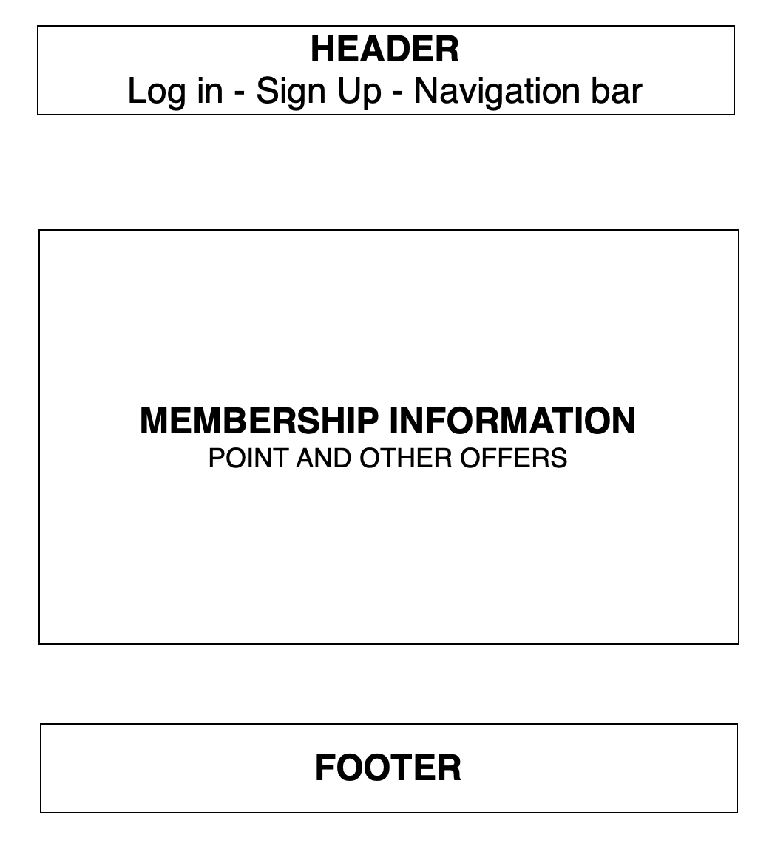

1. **Africa**

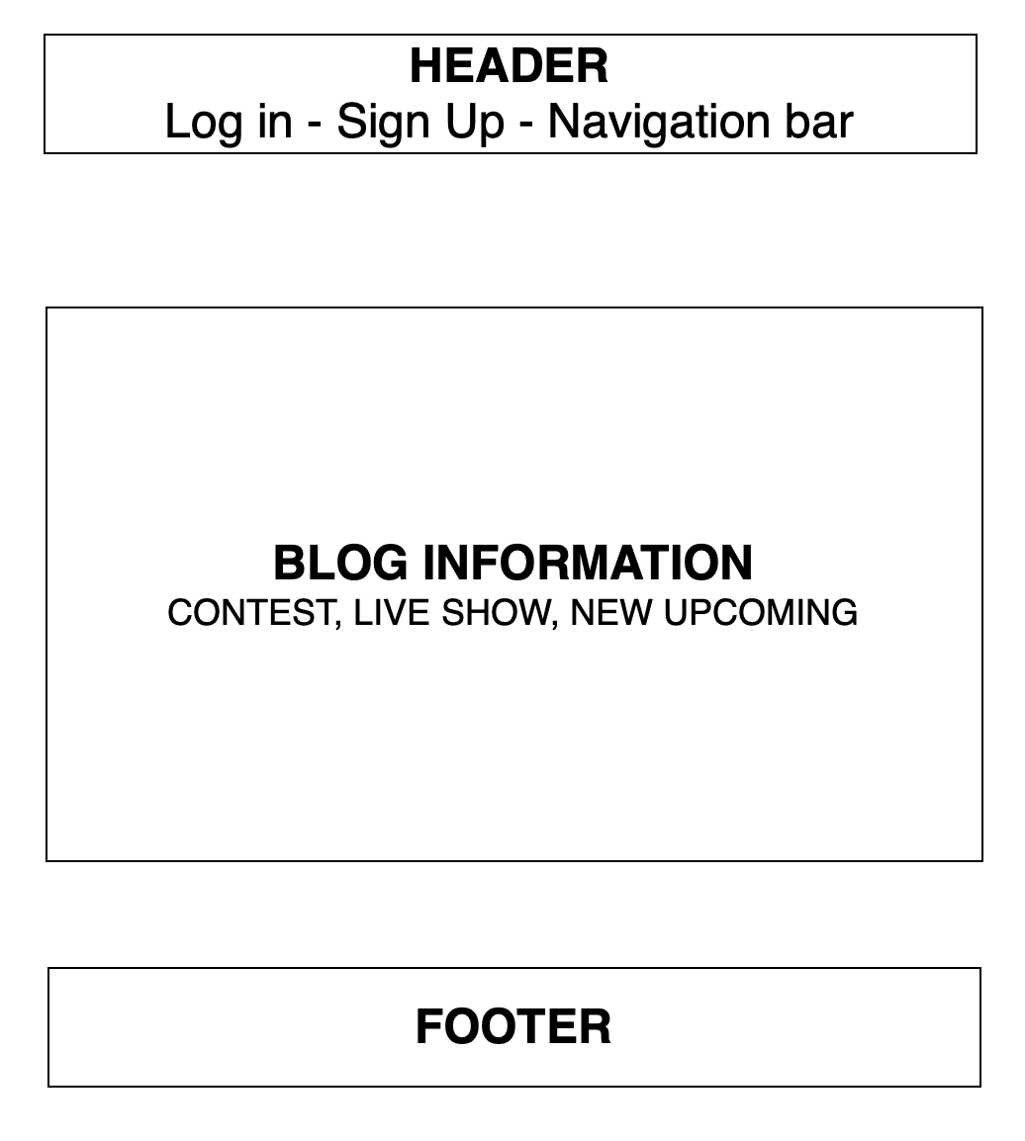

1. **Thing to see & do**

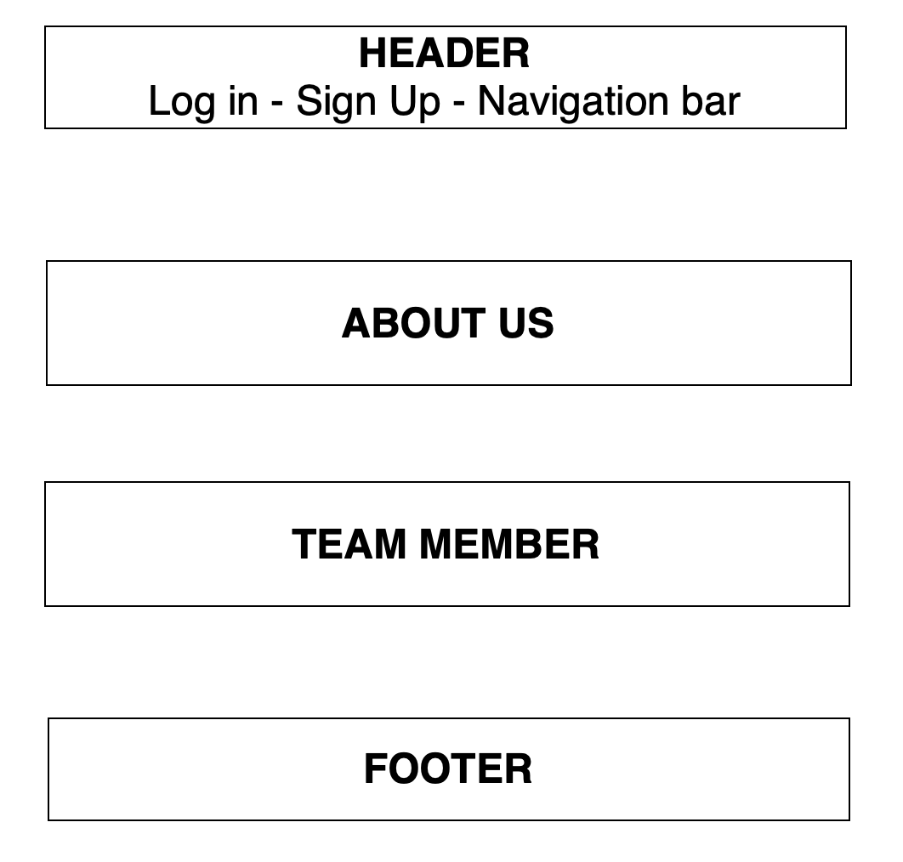

1. **Plan your visit**

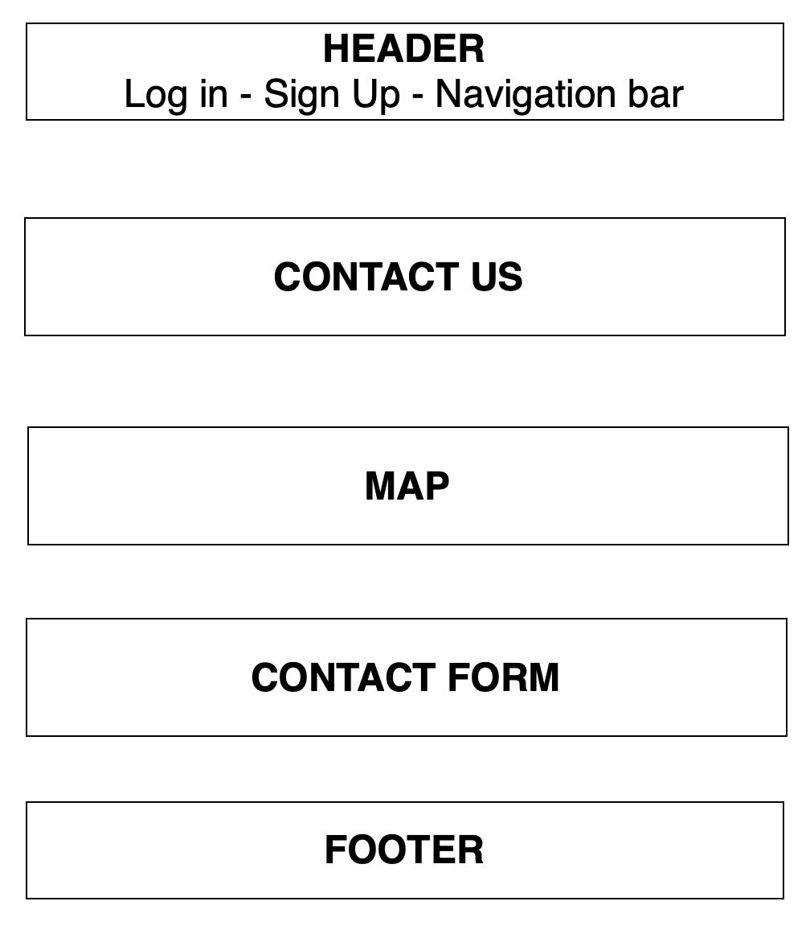

1. **Log in**

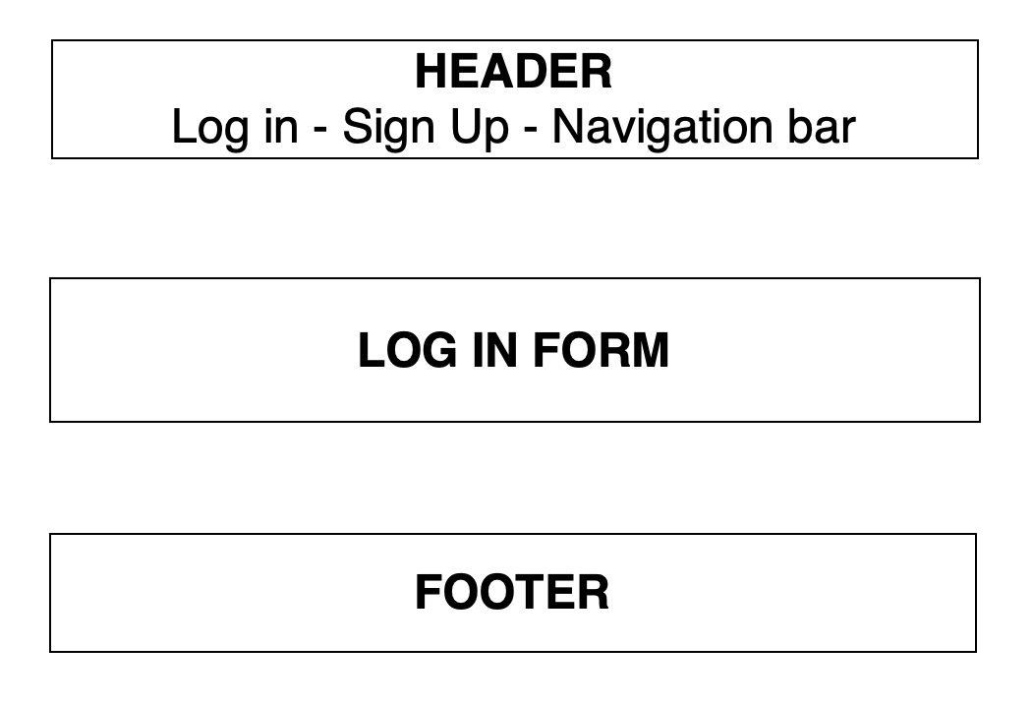

1. **Register**

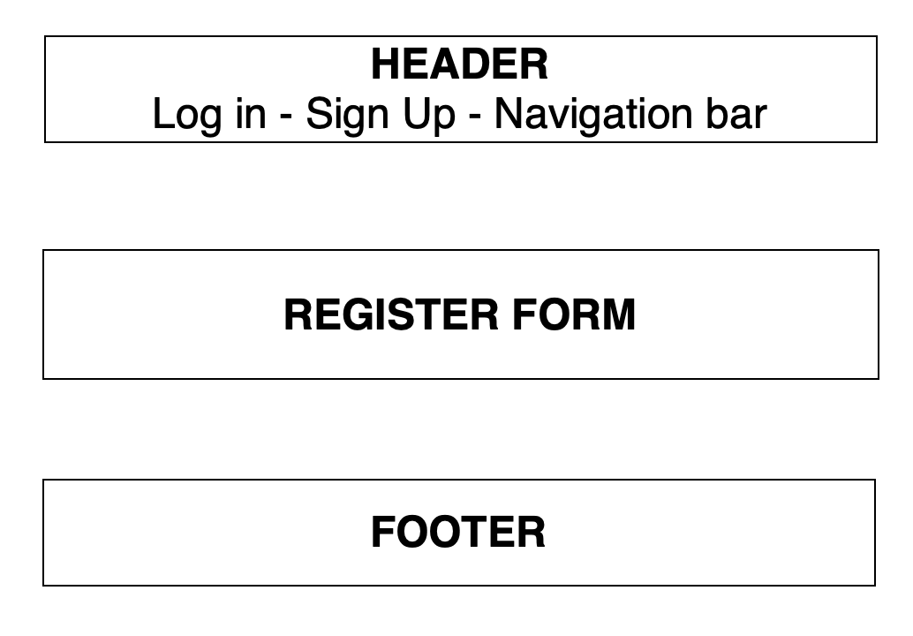



# TASK SHEET REVIEW 2

|  |  |  |  |  |  |  |  |
| --- | --- | --- | --- | --- | --- | --- | --- |
| **Project Ref. No.:**  **eP/Advertisement**  **Portal Management System/01** | | **Project Title:** | **Activity Plan Prepared By:** | **Date of Preparation of Activity Plan:** | | | |
| **Sr.**  **No.** | **Task** | **Actual Start Date** | **Actual Days** | **Team Mate Names** | **Status** |
| 1 | Site map | World wide national park | Thinh | 18-June-20 | 1 | Nhan | Completed |
| 2 | Mock of the website | 18-June-20 | 2 | Thinh | Completed |
| 3 | Task sheet | 18-June-20 | 2 | Truc | Completed |

|  |  |
| --- | --- |
| **Date:** | |
| Signature of Instructor:  **Ms. Le Mong Thuy** | Signature of Team Leader:  **Phan Phuc Thinh** |

# WEBSITE DESCRIPTION

1. **Home Page**
2. Description

Home page displays following information:

* Feature national park such as new album.

1. Screen shot

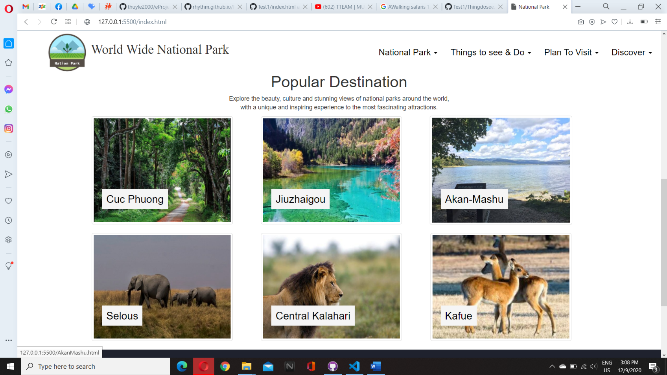

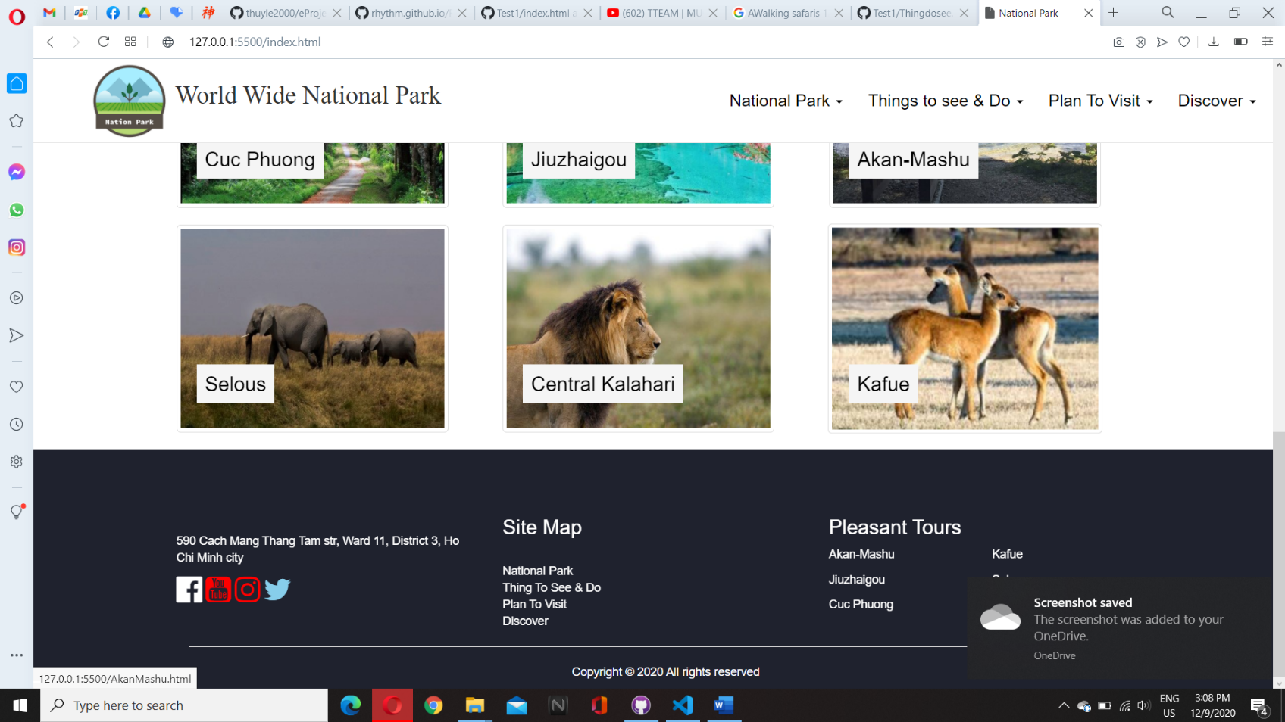

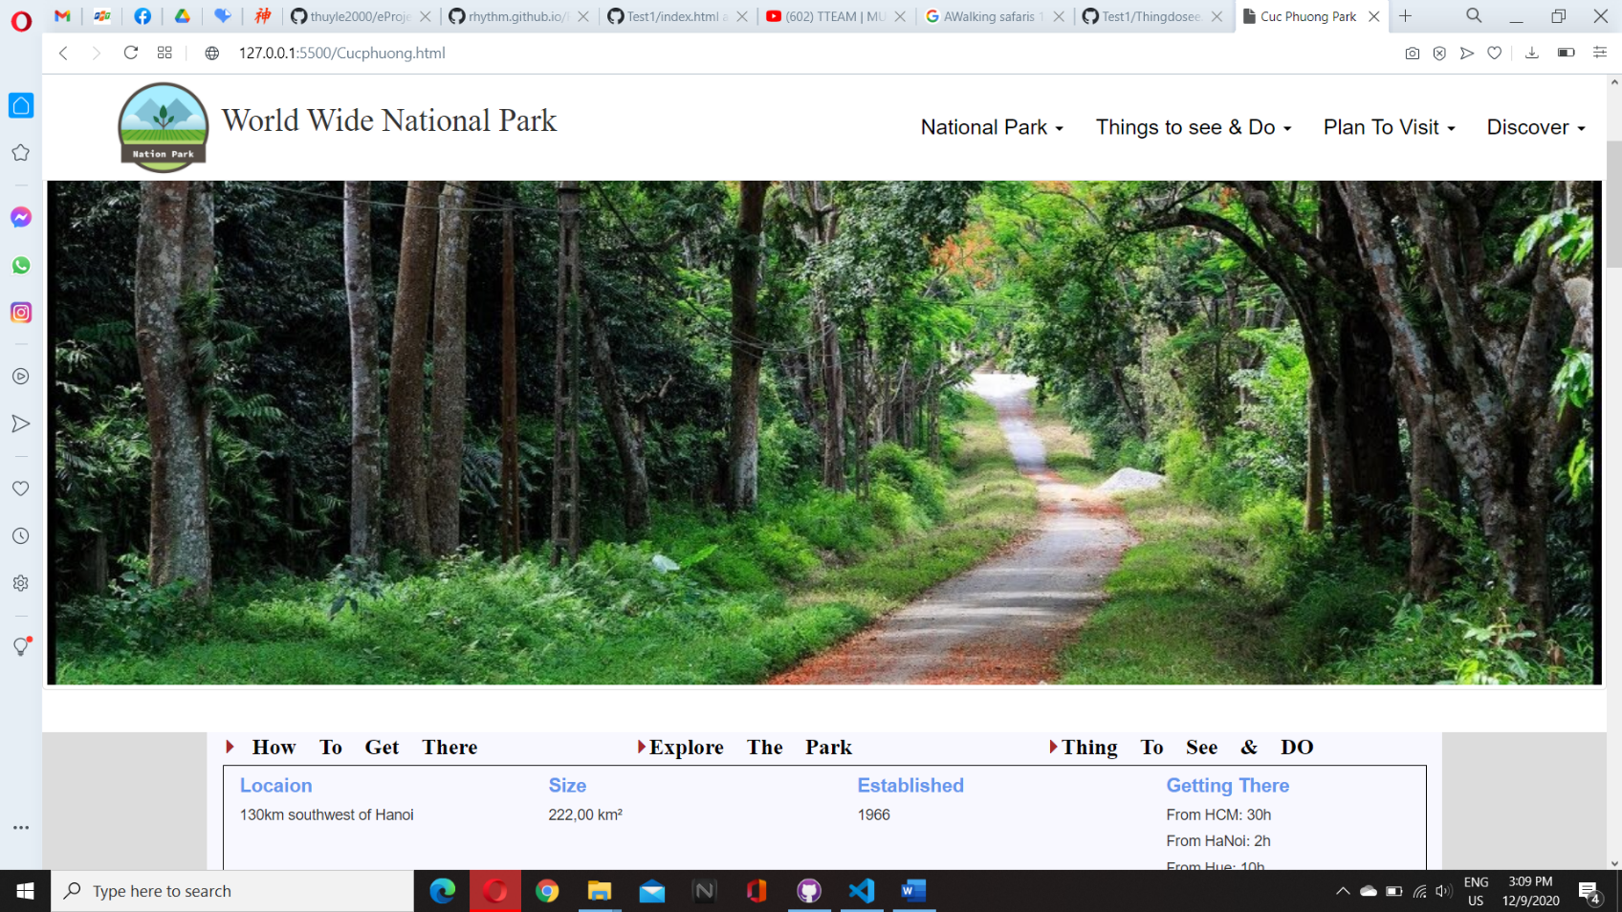

1. **asia**
2. Description

This national park page displays following information:

- website talking about parks in Asia

1. Screen shot

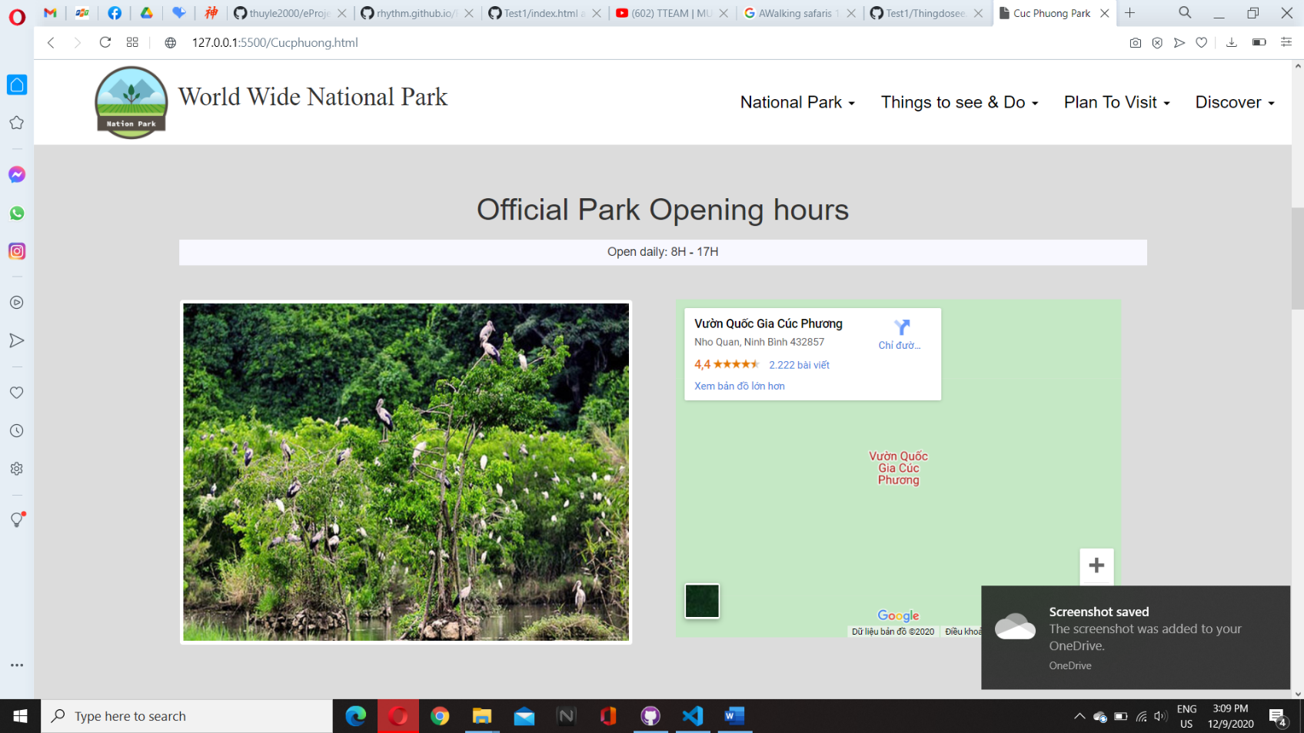

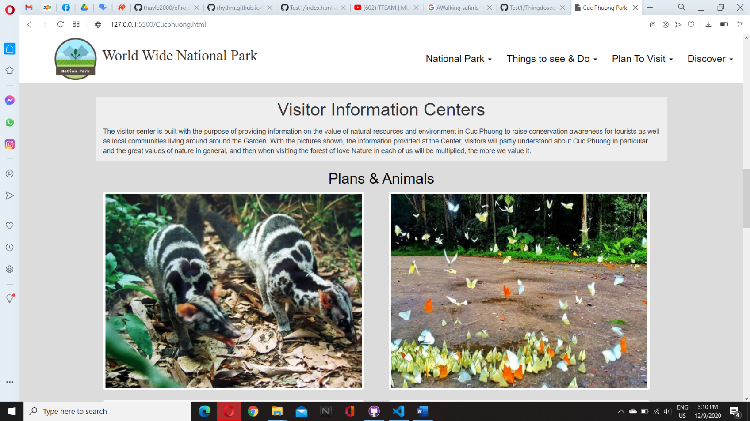

1. **Europe**
2. Description

- website talking about parks in Europe

1. Screen shot

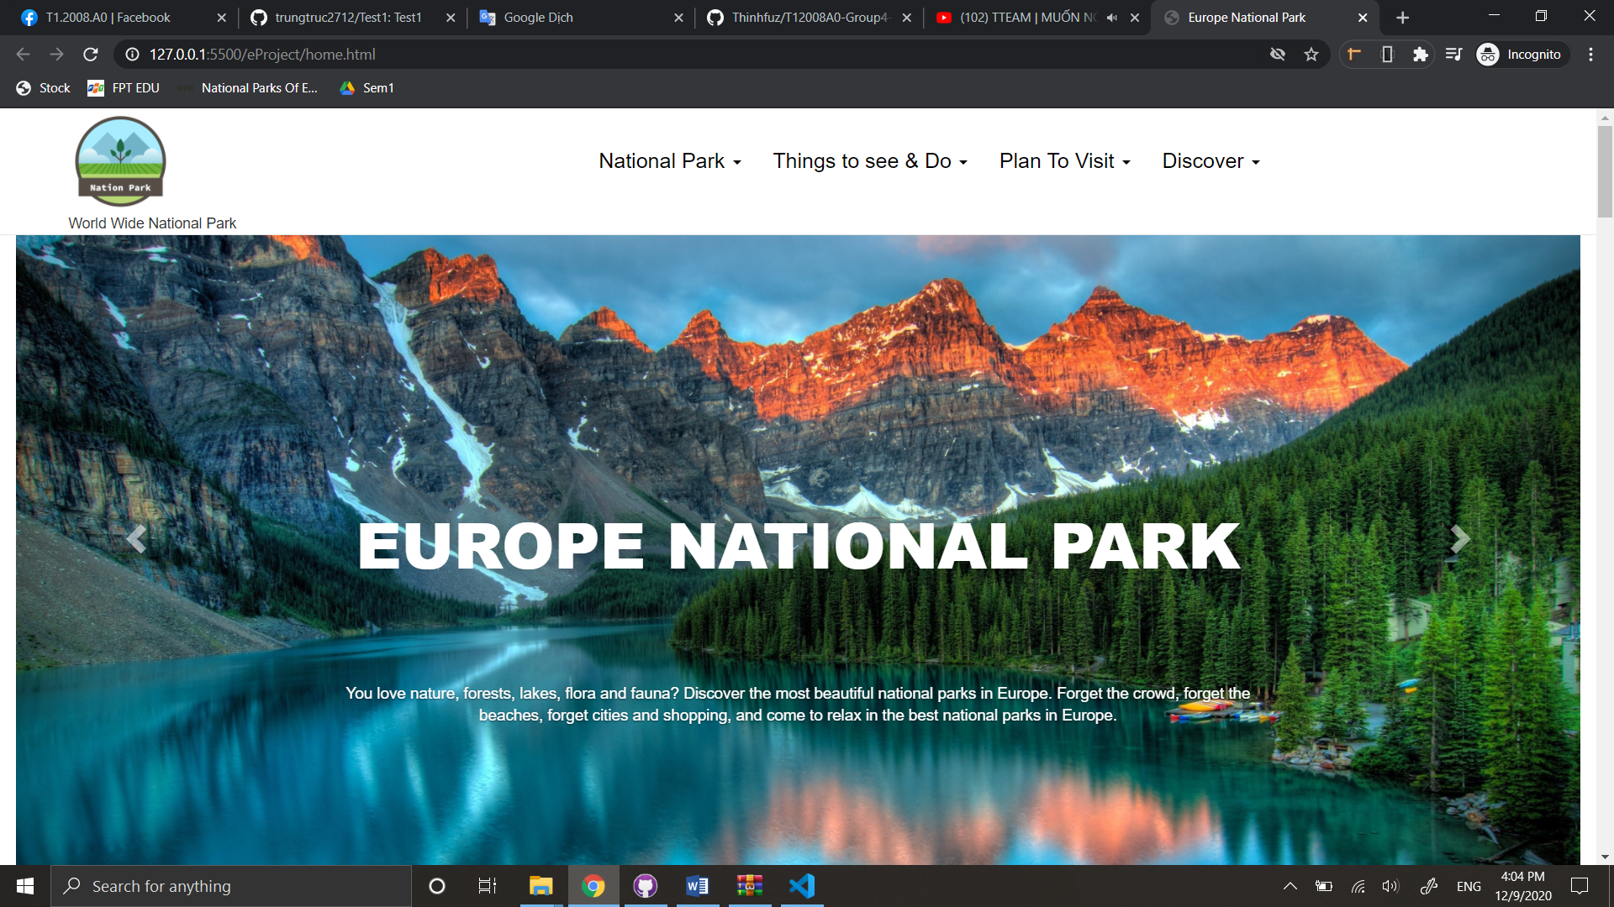

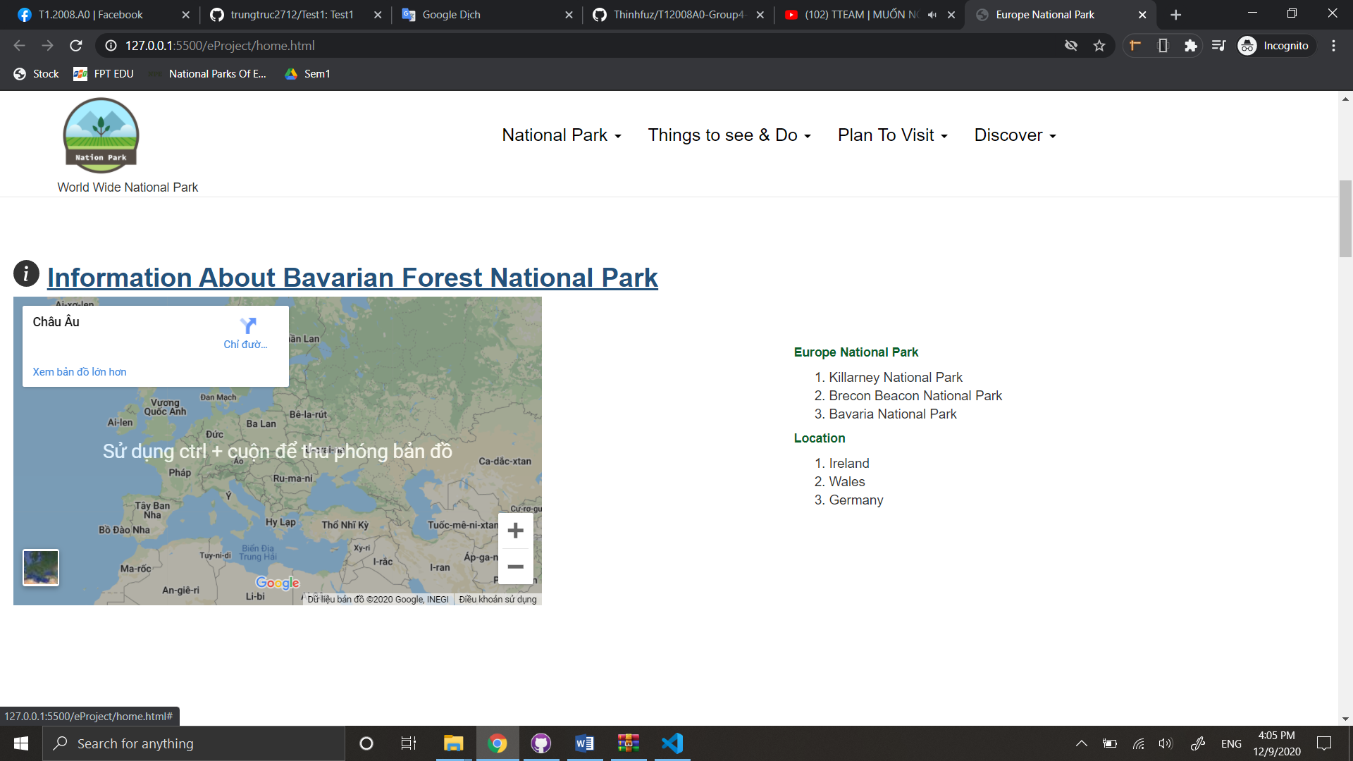

1. **africa**
2. Description

- website talking about parks in Africa

1. Screen shot

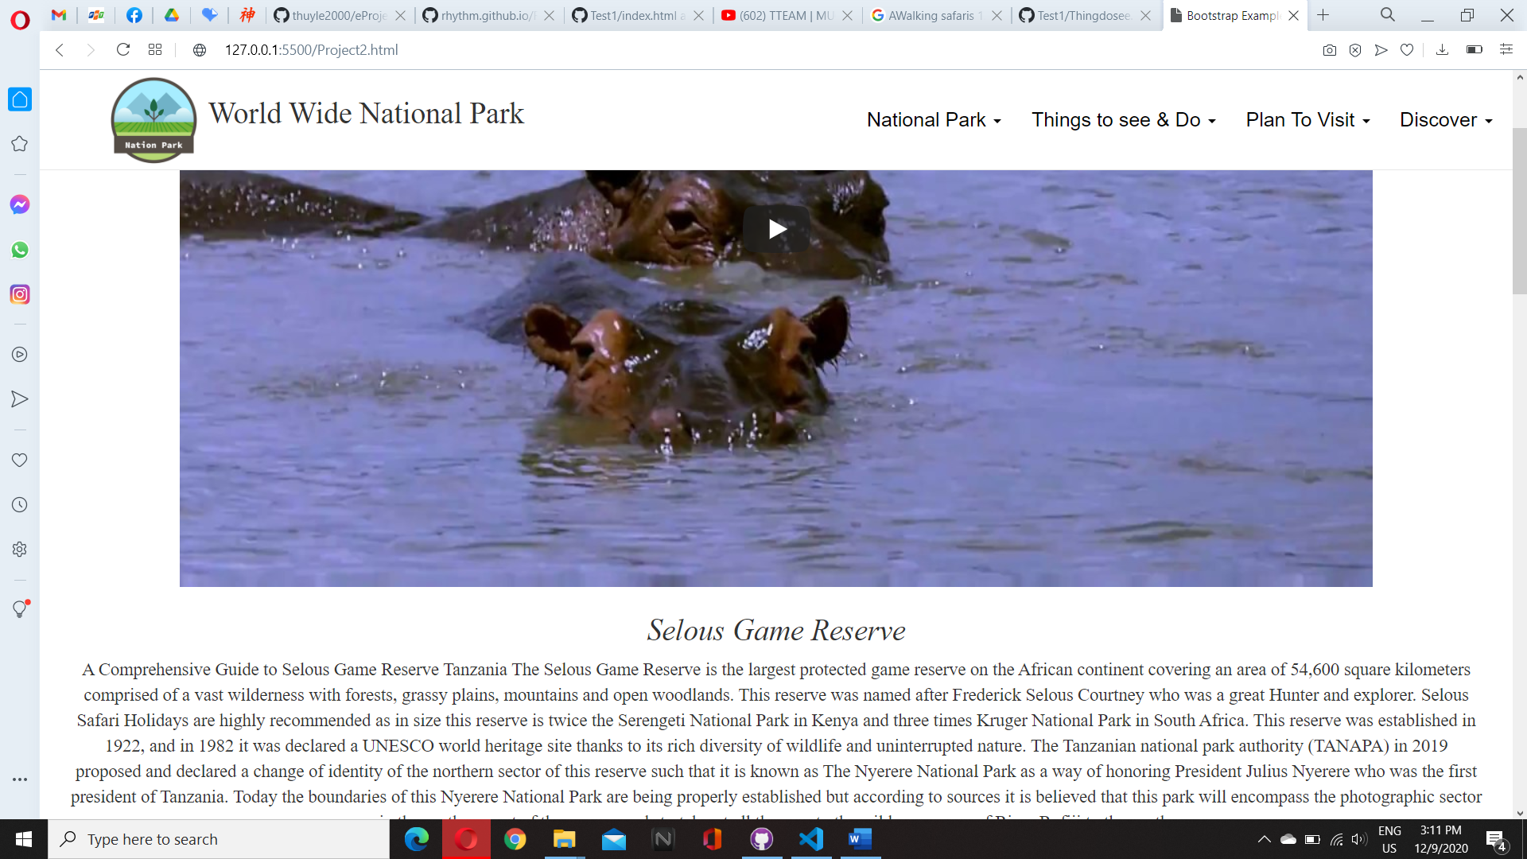

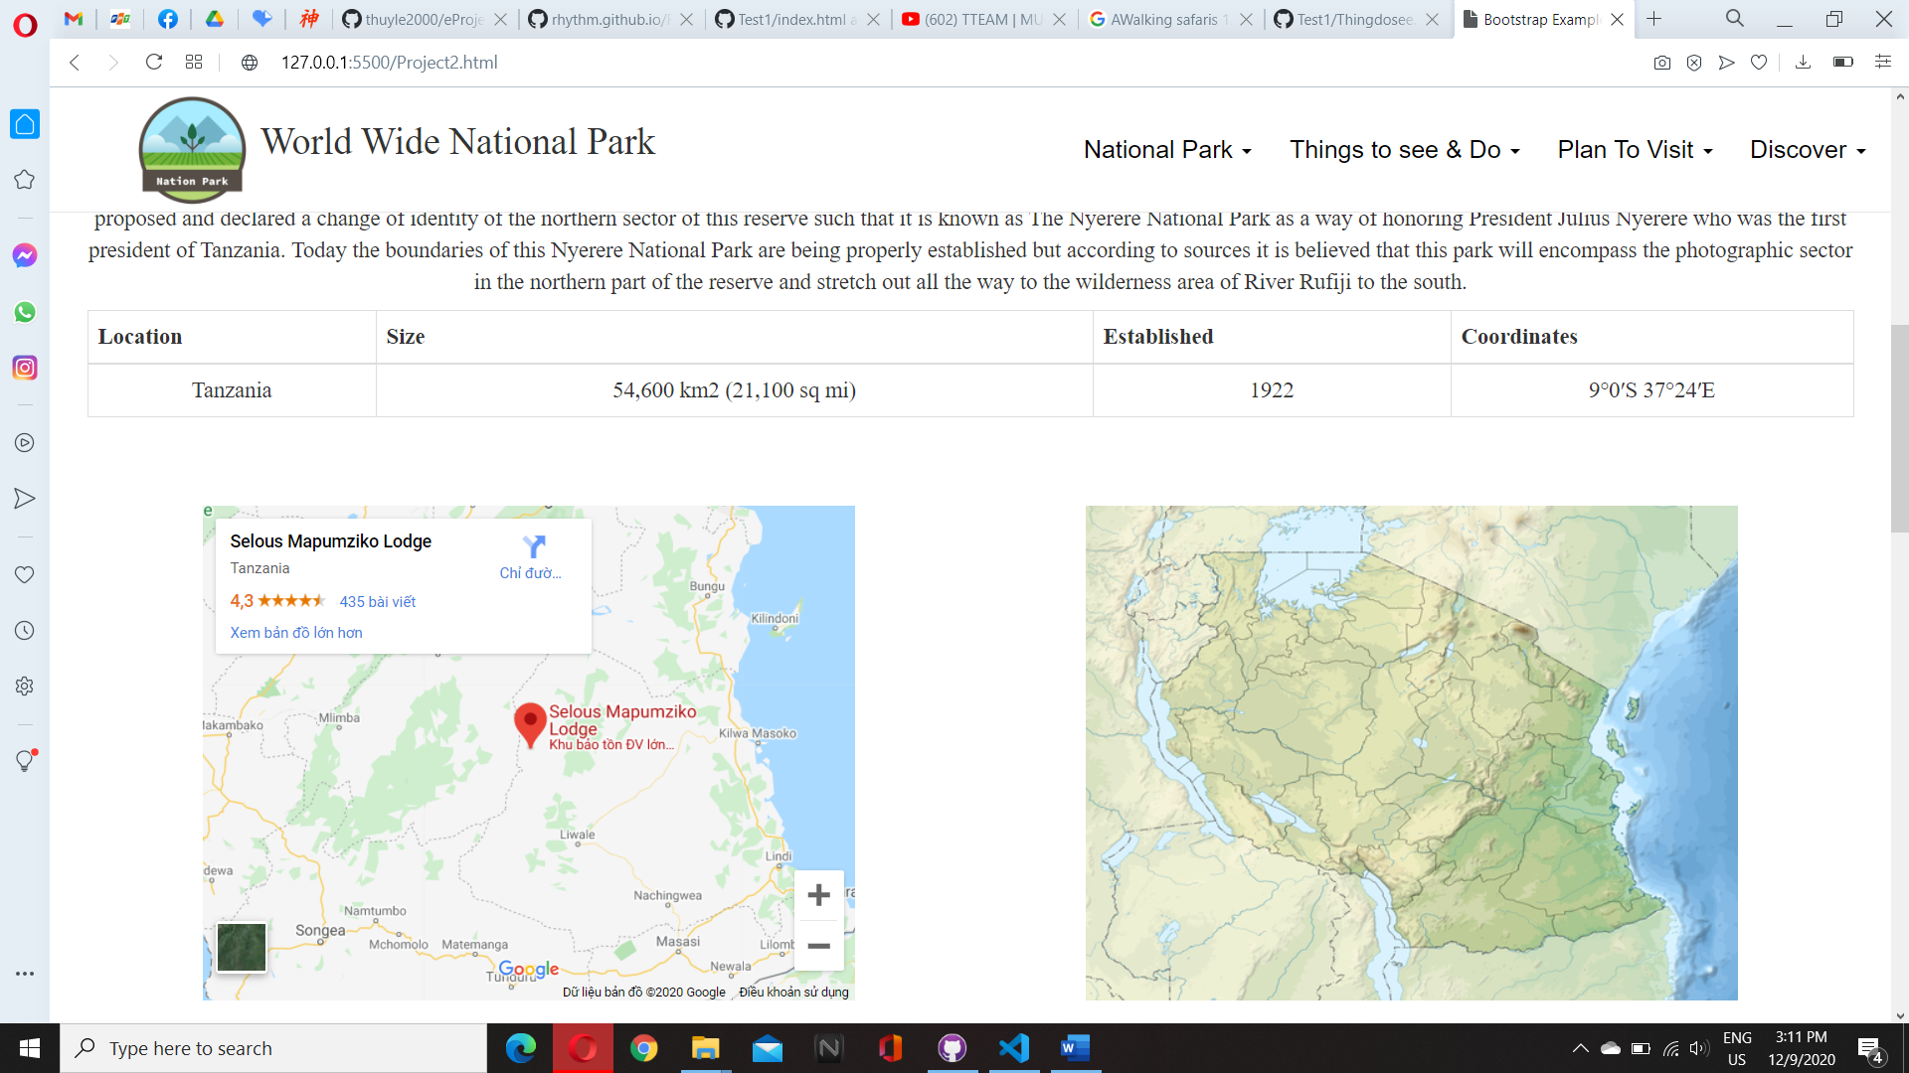

1. **Thing to see & do**
2. Description

-Tourists are welcome to **visit** the national park and learn more about this this place what they usually do, and funny activities make the best trip for you.

1. Screen shot

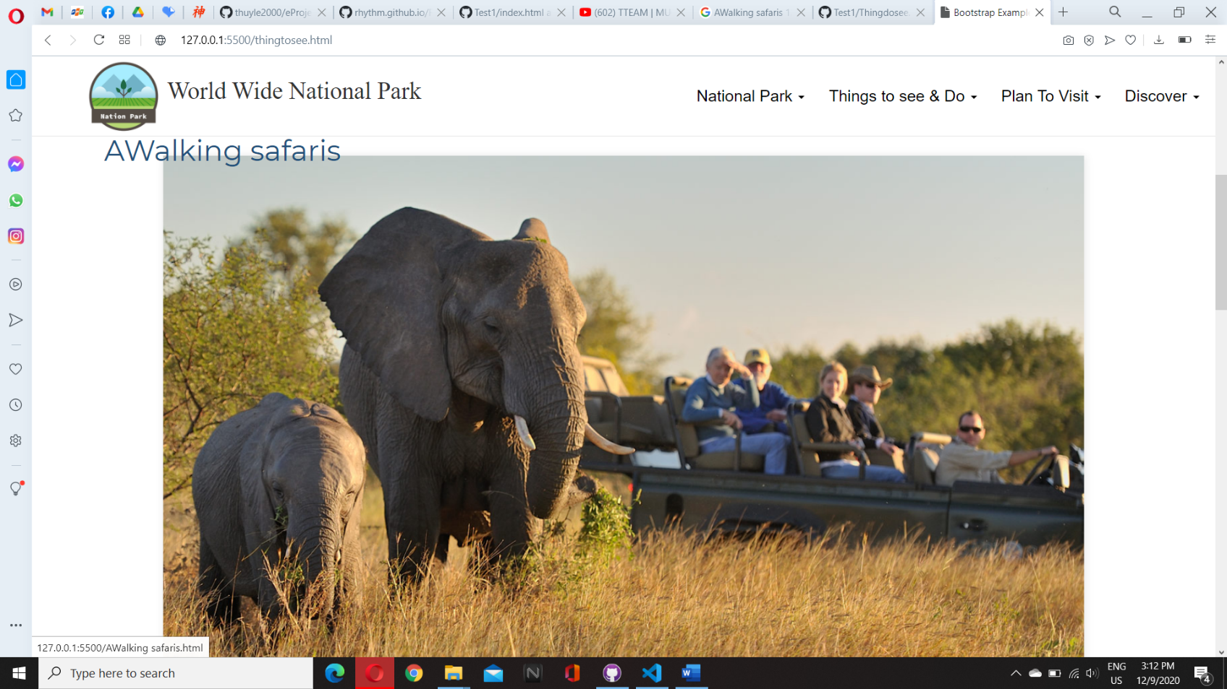

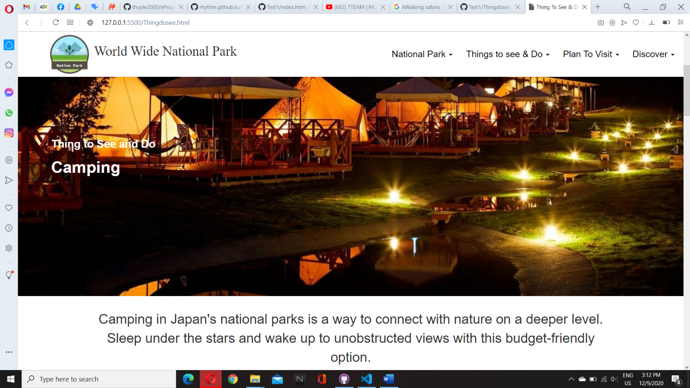

1. **Plan To visit**
2. Description
3. In this, you can find the placement, heritage destination you must travel here. After that, we plan for you the right plan to visit that national park.
4. Screen shot

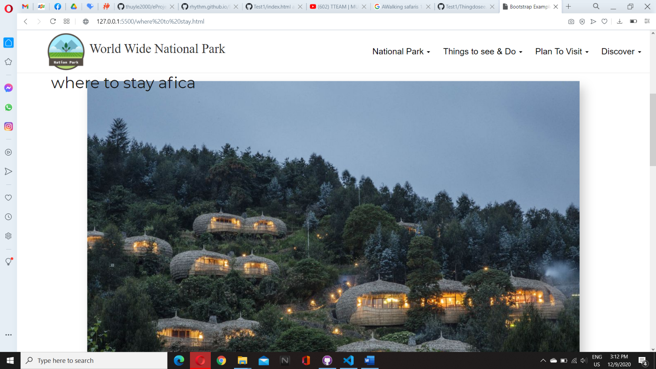

1. **Discover**
2. Description
3. The place where you find something new in natural, biodiversity, animal and plant in whole world.
4. Screen shot

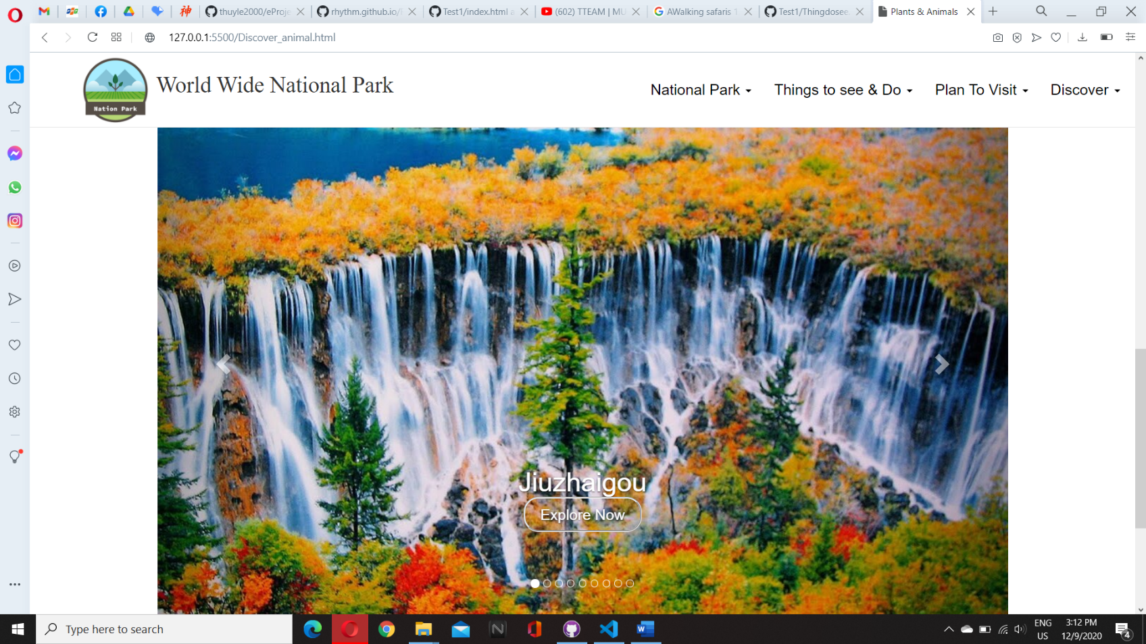

**JAVASCRIPT DESCRIPTION**

1. **Slider javascript**
2. Decrription

- This is the javascript used to hover the image

1. Screen shot

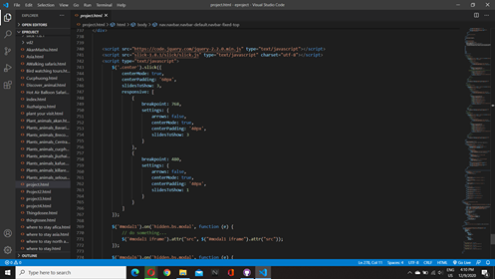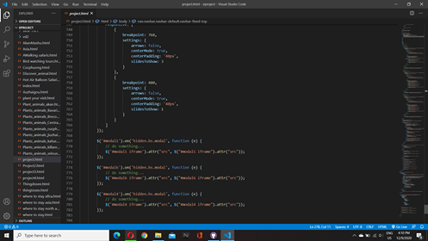

# TASK SHEET REVIEW 3

|  |  |  |  |  |  |  |  |
| --- | --- | --- | --- | --- | --- | --- | --- |
| ***Project Ref. No.:***  ***eP/Advertisement Portal Management System/01*** | | ***Project Title:*** | ***Activity Plan Prepared By:*** | ***Date of Preparation of Activity Plan:*** | | | |
| ***Sr.***  ***No.*** | ***Task*** | ***Actual Start***  ***Date*** | ***Actual Days*** | ***Team Mate***  ***Names*** | ***Status*** |
| *1* | *Home page* | *National park* | *Thinh* | 08-Dec-20 | *1* | *Truc* | *Completed* |
| *2* | *Asia* | 08-Dec-20 | *1* | *Truc* | *Completed* |
| *3* | *North american* | 08-Dec-20 | *1* | *Thinh* | *Completed* |
| *4* | *Africa* | 08-Dec-20 | *1* | *Nhan* | *Completed* |
| *5* | *Plan your visit* | 08-Dec-20 | *1* | *Truc* | *Completed* |
| *6* | *Thing to see & do* | 08-Dec-20 | *1* | *Thinh* | *Completed* |
| *7* | *Discover* | 08-Dec-20 | *1* | *Thinh* | *Completed* |
| *8* | *Plant and animal* | 08-Dec-20 | *1* | *Nhan* | *Completed* |
| *9* | *Europe* |  |  | 08-Dec-20 | *1* | *Thinh* | *Completed* |
| *10* | *Javascrip* |  |  | 08-Dec-20 | *1* | *Nhan* | *Completed* |
| *11* |  |  |  |  |  |  |  |
| *12* |  |  |  |  |  |  |  |
| *13* |  |  |  |  |  |  |  |

|  |  |
| --- | --- |
| **Date:** | |
| Signature of Instructor:  **Ms. Le Mong Thuy** | Signature of Team Leader:  **Phan Phuc Thinh** |